**PERSONAL PROFILE**

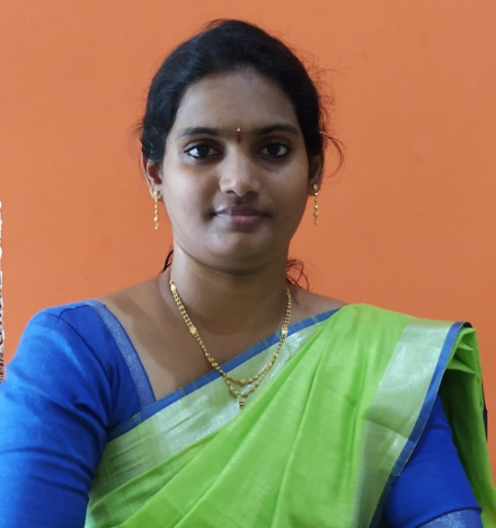

Name: Smt.A.Umatarangini

Qualification: M.A (Ph.D)

Experience: 3 years 4months

Contact Number: 9492630166

Email: taru.aithm@gmail.com

**Educational Qualifications**

| **S.NO** | **COURSE** | **BOARD/**  **UNIVERSITY** | **YEAR OF**  **PASS** | **PERCENTAGE** |
| --- | --- | --- | --- | --- |
| 1 | S.S.C. | BOARDOF  SECONDARY  EDUCATION | 2004 | 75% |
| 2. | INTERMEDIATE | BOARDOF  INTERMEDIATE  EDUCATION | 2006 | 84% |
| 3 | B A | ANDHRA UNIVERSITY, VISAKHAPATNAM | 2009 | 75% |
| 4 | M.A | ANDHRA UNIVERSITY, VISAKHAPATNAM | 2011 | 75% |
| 5 | AP-SET  HISTORY | OSMANIA UNIVERSITY | 2015 | QUALIFIED |

**WORKSHOPS ATTENDED**

* One day state level workshop on NAAC conducted by SCIM government degree college, Tanuku in 2019
* One day state level workshop on “Enhancement of internal quality of NAAC accreditation” at SVRK government degree college (M),NDD on 29th October 2019
* One day national workshop on Human rights:social integration women empowerment on 10th December 2019 at DRG GDC tadepalligudem,westgodavari
* One day national level seminar on” media role in social development” at SVD GDC(W),NDD on 01-02-2020
* UGC sponsored International seminar paper presented on “Telugu literature role in freedom movement” KVR GDC WOMEN (A), Kurnool on 26th February 2020
* One day national workshop on”Intellectual property rights” at SVRK GDC(M),NDD on 11th ,march 2020
* State level seminar ,paper presented on Ancient Indian migrations- A genetic study with molecular approaches” on 27th February,2020
* One day National workshop on “Intellectual property rights “at SVRK GDC(M),NDD on 11th march 2020
* Three days National webinar on “Indian epigraphy with special reference to Tamilanadu” organised by Alagappa university,history department from 15-05-2020 to 17-05-2020
* “Open access resources, tools and techniques for researchers” organised by Dr.B.R.Ambedkar central library AKNU(Rjdy) on 29th may 2020
* National webinar on capital market AMID COVID- way ahead by bhavan’s Vivekananda college on 22nd may 2020
* National webinar on diagnostic techniques for virus detection by SCNR GDC proddutur on 14-05-2020
* National webinar on health management by way foundation & consortium of NGO’S tirupathi on 31-05-2020
* “A Paradigm shift in the post covid world” by pithapuram rajah’S GDC Kakinada on 31-05-2020
* SAS GDC Narayanapuram on contemporary research trends in language ,literature and inter disciplinary studies on 27-06-2020
* A two days international webinar on historical perspectives of pandemics in India by KVR GDC WOMEN (A),Kurnool from 29th june 2020 to 30th june 2020
* National webinar on Indian economy and post lockdown by SVD GDC(W),NDD on 12-06-2020
* National webinar on Role of English language in creating career opportunities conducted by SVD GDC(W),NDD on 11th july 2020
* National webinar on “తెలుగు సాహిత్యం – కులవృత్తుల సంక్షోభం “ on 20-08-2020

**FACULTY DEVELOPMENT PROGRAMMES ATTENDED:**

* Online teaching- learning process using ICT tools for education 4.o” organised by department of information technology, SVPCET nagapur from 8th to 13th june 2020
* SRTMU(NANDED) one week national faculty development programme on “ICT tools for effective teaching learning” from 11th to 16th may 2020
* A two day FDP on virtual teaching –learning moodle the efficient way by MGR Education and research institution from 29th ,30th may 2020
* “Modern teaching evaluation and research methods” from 2nd to 7th june 2020 organised by vinayakarao patil mahavidyalaya,vaijapur.
* 5 day faculty programme conducted by **“CCE”** in “LMS video& pedagogy” on the theme of imaging & shaping of digital education & LMS towardsdevelopment of high-quality e-conten: video making app based on end to end and editing tools open educational resources(OER) OBS studio pedagogy and assessment “from 3rd august 2020 to 7th august 2020
* 5 day faculty programme in History on the theme of “history matters: the past,present and future – social,cultural political and economic foundations” by CCE from 26-07-2020 to 24-07-2020
* 3 day faculty programme on PODCAST from 12-08-2021 to 14-08-2021 conducted by CCE under APSHE.

**Academic credits:**

* Created 6 LMS videos for degree students and also uploaded in CCE website
* Created PODCAST audio files and also uploaded in APSHE website

**PROFESSIONAL EXPERIENCE:**

* SVD GOVERNMENT DEGREE COLLEGE FOR WOMEN ,NIDADAVOLE FROM 2018-2021
* SRR&CVR GOVERNMENT DEGREE COLLEGE VIJAYAWADA 2021 ONWARDS

**IN SERVICE PROGRAMMES ATTENDED:**

* Attended Orientation programme/induction programme at visakhapatnam under HRDI from 13-08-2018 to 26-08-2018
* Successfully completed orientation programme in Ramanujan college under delhi university from 04-06-2020 to 01-07-2020
* completed Refresher course on “managing online classes & co-creating moocs 4.O”
* successfully completed ARPIT course (Refresher course) on **women/gender studies** on 16-02-2020